Aerial Pathfinding Reconnaissance

Jason Gilman

Max Griffith

Mark Johnson

Dilanka Weerasinghe

**Subsystem Reports**

REVISION 1 – Draft

17 November 2020

Subsystem Reports

for

Aerial Pathfinding Reconnaissance

Prepared by:

_____________________________

Jason Gilman Date

_____________________________

Max Griffith Date

_____________________________

Mark Johnson Date

_____________________________

Dilanka Weerasinghe Date

Approved by:

_____________________________

Jason Gilman Date

_____________________________

Prof. S. Kalafatis Date

_____________________________

T/A Date

**Change Record**

|  |  |  |  |  |
| --- | --- | --- | --- | --- |
| **Rev.** | **Date** | **Originator** | **Approvals** | **Description** |
| **1** | 11/17/2020 | Jason Gilman |  | Draft Release |

Table of Contents

Table of Contents III

List of Figures VI

List of Tables VII

1. Introduction 1

2. Definitions 2

3. Data Collection and Drone Control 3

3.1. Subsystem Introduction 3

3.2. Aerial Drone 3

3.2.1. Description 3

3.2.2. Communication 3

3.2.3. Input Data 3

3.2.4. Physical Characteristics 4

3.2.5. Aerial Obstacle Avoidance 4

3.2.6. Validations 4

3.2.7. Calculations 6

3.3. Land Rover 6

3.3.1. Radio Transmission 7

3.3.2. Microcontroller Transmission 7

3.3.3. Validations 7

3.3.4. Calculations 8

3.4. Sensor System 8

3.4.1. Camera 8

3.4.2. Ultrasonic Sensors 9

3.4.3. Validations 10

3.4.4. Calculations 10

3.5. Subsystem Conclusion 11

4. Computer Vision and Mapping 12

4.1. Subsystem Introduction 12

4.2. Moving Object Removal 12

4.2.1. Description 12

4.2.2. Algorithm 12

4.2.3. Validation 12

4.3. Image Stitching 13

4.3.1. Description 13

4.3.2. Algorithm 13

4.3.3. Validation 14

4.4. Depth Inferencing 14

4.4.1. Description 14

4.4.2. Algorithm 14

4.4.3. Validation 15

4.5. Depth Map Merging 15

4.5.1. Description 15

4.5.2. Algorithm 15

4.5.3. Validation 17

4.6. Gradient Derivation 17

4.6.1. Description 17

4.6.2. Algorithm 18

4.6.3. Validation 18

4.7. Obstacle Delineation 18

4.7.1. Description 18

4.7.2. Algorithm 18

4.7.3. Validation 19

4.8. Subsystem Conclusion 19

5. Pathfinding and Drone Detection 20

5.1. Subsystem Introduction 20

5.2. Stack Drone Algorithm 20

5.2.1. Description 20

5.2.2. Algorithm 21

5.2.3. Validation 22

5.3. Resolution Decrease Algorithm 22

5.3.1. Description 22

5.3.2. Algorithm 23

5.3.3. Validation 23

5.4. Subsystem Conclusion 24

6. Device Networking and User Interface 26

6.1. Subsystem Introduction 26

6.2. Network Infrastructure 26

6.2.1. Description 26

6.2.2. Access Points 26

6.2.3. Client 27

6.3. Drone Servers 27

6.3.1. Description 27

6.3.2. Software 28

6.3.3. Communication 28

6.4. User Interface 29

6.4.1. Description 29

6.4.2. Application Structure 30

6.4.3. Mapping Tool 30

6.4.4. Communication Tasks 32

6.4.5. Error Handling 32

6.5. Subsystem Validation 33

6.5.1. Networking Validation 33

6.5.2. UI Logic Validations 34

6.5.3. Accessibility Validations 34

6.6. Subsystem Conclusion 35

*Appendix A: Minor Computer Vision & Mapping Stages* 36

*Appendix B: Checking for re-used coordinate* 36

List of Figures

Figure 1. Orientation and Video Capture 4

Figure 2. Return Home / Battery 4

Figure 3. Physical Drone 5

Figure 4. Rover Build 6

Figure 5. Drone Camera Mount 9

Figure 6. Ultrasonic Mount 10

Figure 7. Image Stitching Perspective Problem 13

Figure 8. Depth Map Merging Algorithm 16

Figure 9. Full CV&M Pipeline Example 19

Figure 10. Software Interaction 20

Figure 5. Sample Map 21

Figure 7. Cyclic Path Solved 22

Figure 8. Decreased Resolution Map 23

Figure 9. 4x2 Decreased Map 24

Figure 10. Error With a 5x2 Decreased Map 24

Figure 11. Overview of Network Infrastructure 26

Figure 12. Raspberry Pi 3B+ with TL-WN722N 27

Figure 13. HTTP Request Architecture 29

Figure 14. Mapping Tool: Valid and Invalid Selection 31

Figure 15. Map Quadrant Size 31

Figure 16. Navigation Instruction File 32

Figure 17. User Interface Error Messages 33

Figure 19. Coordinate Distance Calculation 34

List of Tables

Table 1. Physical Drone Characteristics 6

Table 2. Rover Characteristics 8

Table 3. Sensor Characteristics 10

Table 4. Client System Requirements 27

Table 5. Drone Server API Endpoints 28

Table 6. Desktop Application Stack 30

Table 4. Networking Validations 34

Table 5. UI Logic Validations 34

Table 9. Accessibility Validations 35

# Introduction

The Aerial Pathfinding Reconnaissance System (APRS) is designed to navigate a blind ground vehicle using only data collected by a prior drone pass. First, the user will select their survey area and start/end points. Then, the drone will autonomously travel to and survey the area. It surveys the area by taking a series of downward videos over the area. Once the drone returns, the data will be collected by the user’ for analysis. This analysis begins by converting the videos into images, removing all non-stationary obstacles as per our sponsor’s requirement. These videos are then used to infer elevation data through stereoscopy, which is then analyzed further to produce an obstacle map based on the ground vehicle’s capabilities. Once analysis is complete, the generated instructions can be relayed to the ground vehicle and it can begin its traversal of the path from its initial starting location.

The APRS is divided into four subsystems:

* Drone Control & Data Collection
* Computer Vision & Mapping
* Pathfinding & Drone Detection
* Device Networking & UI

Each of these four subsystems has been independently developed by one of our four team members since the beginning of Fall 2020, and all subsystems have reached the final stages of their development. Since each of the subsystems is either complete or mostly complete, the development of the APRS is on track for completion by the end of Spring 2021. The following sections report on the status of each individual subsystem and have been authored by their sole developers.

For reference, all source code is available on the team GitHub repository at:

<https://github.tamu.edu/jasongilman/Aerial-Pathfinding-Reconnaissance-System>

# Definitions

API – Application Programming Interface

APRS – Aerial Pathfinding Reconnaissance System

FOV – Field of View

UI – User Interface

RaspPi – Raspberry Pi

# Data Collection and Drone Control

## Subsystem Introduction

The purpose of the Data Collection and drone control subsystem is to interface the physical components of the APRS system to the UI and other subsystems. Because the purpose of the APRS system is to navigate and survey an area, it is critical to confirm that the physical components of the system are functional. For this subsystem there are three major components. An aerial drone that will fly and survey an area, a land rover that will navigate the area surveyed by the aerial drone and a senor system that will collect all the data that will be sent to the computer vision system.

## Aerial Drone

### Description

The purpose of the aerial drone is to survey an area. Given this requirement the drone needs to move from location to location and gather data from each point. To accomplish this task the APRS system is using a Tarot 650 v2 drone. This drone is capable of carrying large loads and has a long flight time. Two elements that are vital to making sure the drone can navigate through a large area. The Tarot is using an mRo AUAV x2.1 flight controller with the ArduPilot firmware. Connected to the drone is a Raspberry Pi running Raspbian. The flight controller acts as a median between the microcontroller which controls the logic of the flight path and the sensors and motors that move the drone.

### Communication

Because the mRo is a flight controller that utilizes the ArduPilot firmware it can be simulated to show the exact commands that the flight controller will follow. To send packeted commands to the flight controller the ArduPilot family of controllers uses the MAVproxy and MAVlink protocols to decode and encode serial commands. These commands can be sent literally through the serial port on the Pi or can be decoded by a third-party software such as Drone Kit. In order to have the drone follow the required commands the APRS uses a mix of both methods.

In case of aerial emergency, the drone control can be overridden via a handheld controller. The handled radio controller connected to the drone is a Tannaris X9 lite. This controller has the necessary functionality to change the flight controller from its auto mode where it will follow specified mission commands to the manual mode where all high-level movement commands are completed with the Tannaris.

### Input Data

From the UI subsystem the Drone will read in coordinates to follow the UI subsystem provides an altitude above ground and an orientation to follow the program that controls the Drone will read in the attitude and orientation (yaw) information to initialize the flight of the drone. The Pi will read in the initialization information and begin the read in latitude and longitude point that the program will turn into mission commands. These commands are then encoded into MAVproxy messages that are sent to the flight controller that the drone will follow.

### Physical Characteristics

In order to be operational, the drone must have a body, four quad motors, a flight controller, a battery, and a controller. In order to be functional for the APRS the drone has the additional requirements of a Pi, a GPS and other sensors outlined in (3.5). All these systems have been attached to the drone body and are functional separately.

### Aerial Obstacle Avoidance

In order to perform obstacle avoidance stunts while in the air the drone uses a series of ultrasonic sensors mounted to the drone (3.4.2). While the drone is following mission, points outlined in the program the drone will always fly straight forward. The groundspeed (speed of the drone over the ground) is determined by the command sent. The ultrasonic sensor located in the front of the drone will detect an obstacle. If an obstacle exists within 3 meters the ultrasonic sensor will place the drone in a state of obstacle avoidance.

In this state of obstacle avoidance, the drone will orient itself straight up and then move in the cardinal directions given the input from the ultrasonic sensors. It will move half a meter at a time to remain far from the obstacles. Once all obstacles are out of the way it will return to the autonomous mode where it will follow the mission points.

### Validations

To validate the programming of the drone several simulations were used. For any flight controller in the ArduPilot family a software in the loop program can be calibrated to act as both the flight controller and the drone. All messages sent to the drone can display their operating capacity through the simulator.

Figure 1. Orientation and Video Capture

Figure 2. Return Home / Battery

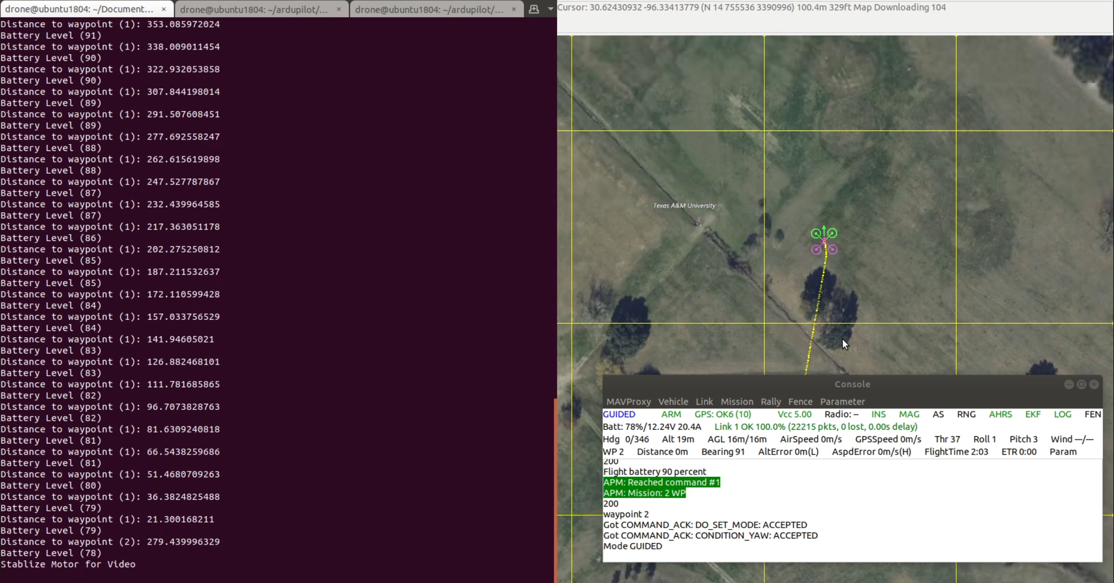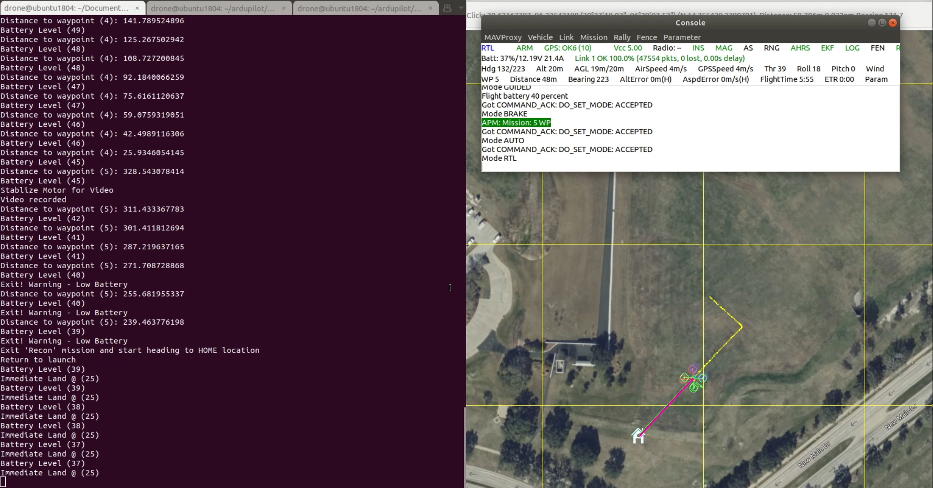

This simulator was used to test the following sub-validations of the Drone subsystem.

* Coordinates Received – From the UI (6.4).
* Flight activated – Drone arms itself and begins liftoff.
* Mission points Followed – Drone will follow all mission point even after interrupted and resumed.
* Battery warning and landing – Drone will return to launch site at a given battery level and in case of dire emergency will land straight down immediately to prevent catastrophic failure.
* Vehicle Mode changing – To account for manual override, obstacle avoidance and ground video.
* Camera Wait time and operation – The Drone will change its orientation to match north perform a BRAKE and wait required amount of time for video.
* MAVlink messages decoded – To send serial packets to flight controller.

Figure 3. Physical Drone

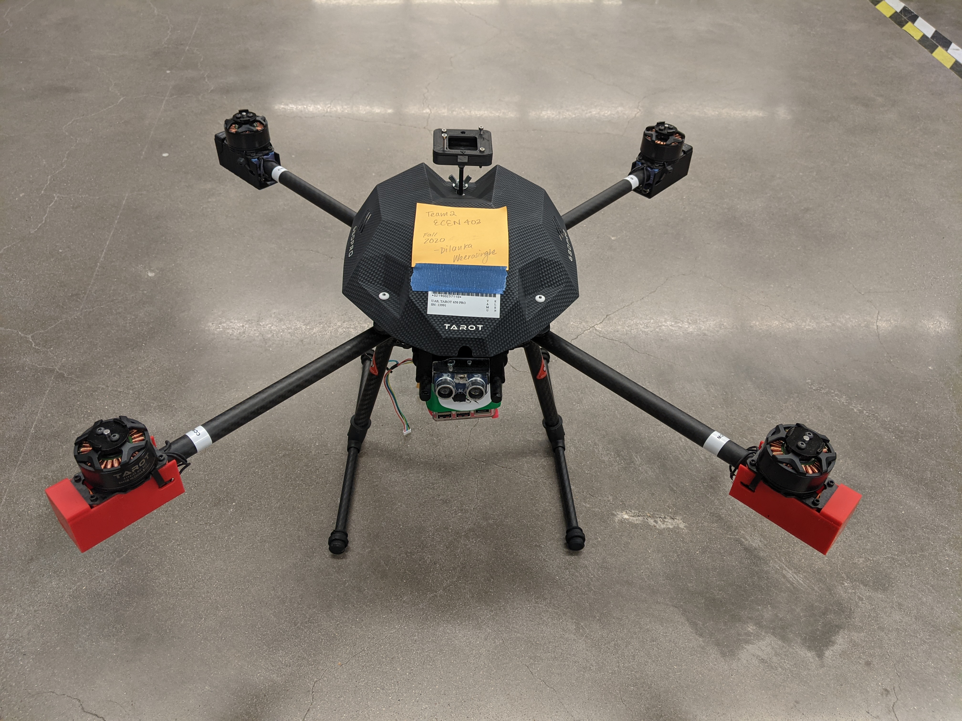

Validations performed on the physical state of the drone.

* Lipo charges the motors and flight controller.
* Flight controller powers the Pi.
* Pi powers logic and data collection sensors.
* GPS receives power with GPS port on flight controller.
* Accelerometer and Gyroscope show correct orientation on flight controller.
* Tannaris x9 lite powers on and bus connection to RC receiver.

### Calculations



Table 1. Physical Drone Characteristics

## Land Rover

The Land Rover subsystem is the final section of the APRS design. Referenced previously in the Introduction (3.1) the Land Rover will navigate the given area using simple directions from the Path Finding and Drone Detection subsystem (5.0). In this subsystem the goal was to provide a simple interface between drone commands that Path finding algorithm can follow. The land rover/drone will use a Raspberry Pi to communicate with the Communication subsystem (6.2.2). Here it will receive a python script to follow specified commands. The main driver for the rover is a Sabretooth 2x25 motor controller that outputs to all 4 DC motors on the rover. This Sabretooth controller can take several different types of command inputs to move the rover. The two main inputs used in the APRS are RC control and serial command.

Figure 4. Rover Build

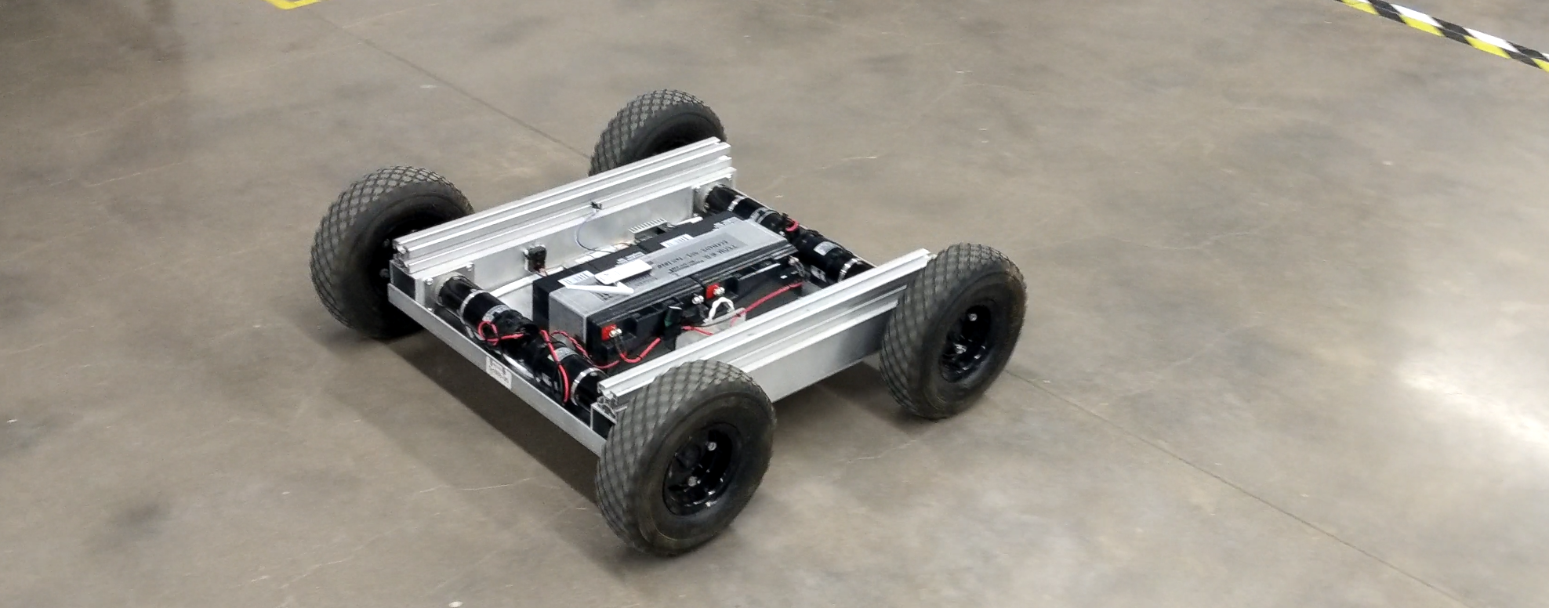

### Radio Transmission

One aspect of controlling the land drone is to get it to its starting location. Because the land Rover weight 31 kg it is not easily movable by hand. To combat this the Drone will instead use an RC controller to get to its initial start location. The radio transmission is powered by the sabretooth controllers 5V output and received very simple gimble commands from a controller. In radio mode the rover is easily moveable from location to location and can even climb in rigorous climates.

### Microcontroller Transmission

The rover is capable of moving using serial commands from a microcontroller. The Raspberry Pi sends serial packets to the sabretooth controller which interprets speed data and emergency stops. For the Pathfinding subsystem this subsystem uses a simple command to send the rover to specified locations. Because of the restrictions placed on sensor data applicable to the land rover it is not capable of detecting obstacles on its own or knowing its location. Therefore, the system has to be calibrated for the environment that it is navigating. Without the restriction of no sensors the rover could be used with a Pixhawk or other telemetry module with an accelerometer and gyroscope to perform internal navigation. The accuracy of the simple movements only lowers as the length of the course increases.

### Validations

To validate the movement of the rover physical components were tested for power and efficiency. All components were able to be powered correctly and received voltages within the given range of valid power draw for the components. The rover is able to move linearly in any path with simple commands for turning, stopping, and traversing a certain distance. Like mentioned in 3.3.2, the system needs to be calibrated for its area and therefore its accuracy lowers as the length of the course increases. While this accuracy has not been tested on a large scale the rover performs within 3% of the required distance traveled while in the microcontroller transmission mode. This was tested by measuring the required distance and the time the rover takes to move that distance. The simple class for simple movement is complete and the rover easily moves in a grid like pattern.

* Rover moves in a grid like pattern
* Simple class created for low- and high-level movement

### Calculations

Table 2. Rover Characteristics



## Sensor System

The sensor subsystem handles the data collection and obstacle avoidance on the APRS. Because the Land rover lacks the sensors required to navigate on its own it needs a way of finding out what obstacles exist in its way. To manage this a sensor system is placed on the aerial drone that will gather the data necessary to perform navigation on for the land rover.

### Camera

The camera system uses the raspberry pi camera module to record video. In order to gather the data necessary, the computer vision subsystem (4.0) requires a left and right eyesight of the ground. Therefore, the camera, when observing the ground from its mounting location on the drone, will take two videos from slightly different locations in the air in order to grab a left and right eye video to create a depth map. The reason the drone grabs video instead of images of the ground is to remove any moving obstacles from the ground. As part of the design constraints the APRS will remove any moving obstacles from the area. To do this a video is required. The camera will take a full resolution 1080p image at 15 frames per second. The camera is capable of taking all kinds of different image sizes. For calibration purposes this can change given additional requirements from the Computer Vision subsystem. One important note is that the FOV of the camera is deterministic of the altitude and distance that the drone needs to travel while in the air. Using a simple geometric equation, the altitude of the drone can be determined by the number of steps required to take the drone. If the drone is flying higher in the air it will need to take less steps to collect the information in a large area. The RaspPi camera module has a floored FOV of 56 degrees. This makes it difficult to survey a large area given the amount of flight time necessary to record stationary video. Although this is a give and take scenario with the computer vision aspect of the APRS a balance can be found once more testing is put into determining the optimal altitude of the drone.

The camera stores its videos given the timestamp and the GPS location. This is subject to change as the Computer vision subsystem makes additional changes to the how it needs to interpret the video data. The RaspPi records in the .h264 format. This is similar to an .mp4 without the addition of .mp3 audio. While this subsystem does not make any changes to the format of the video this is capable in the future. The video is hardware encoded on the RaspPi.

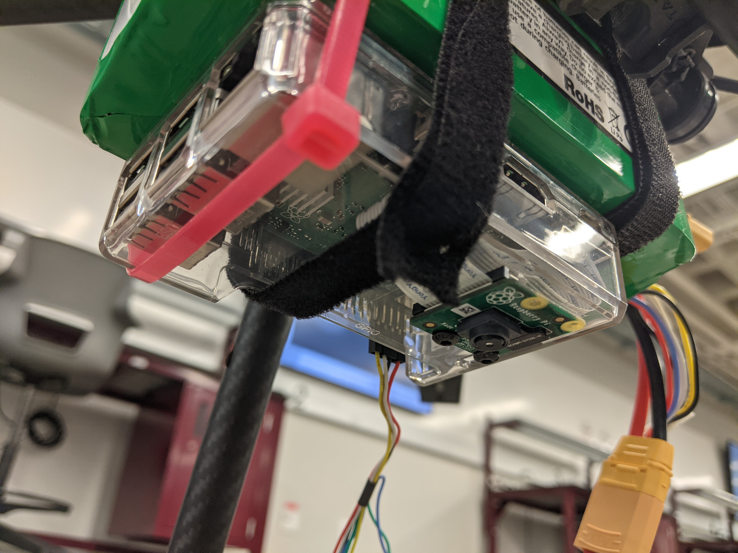

Figure 5. Drone Camera Mount

### Ultrasonic Sensors

Like mentioned in Aerial obstacle avoidance (3.2.5), in order to perform obstacle avoidance stunts while in the air the drone uses a series of ultrasonic sensors mounted to the drone. While the drone is following mission, points outlined in the program the drone will always fly straight forward. The groundspeed (speed of the drone over the ground) is determined by the command sent. The ultrasonic sensor located in the front of the drone will detect an obstacle. If an obstacle exists within 2 meters the ultrasonic sensor will place the drone in a state of obstacle avoidance.

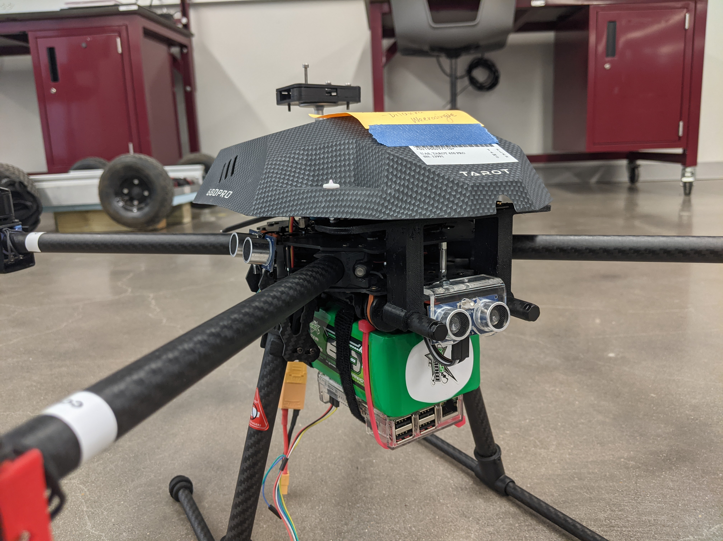

Figure 6. Ultrasonic Mount

The ultrasonic sensors are mounted to the drone in all 4 cardinal directions. They are capable of detecting an obstacle within 0.02m to 4m this is within the range calculated in validations. A distance of 2 meters was chosen as the cutoff distance because in testing it was shown to be reasonably accurate in terms of how the sensors performed.

### Validations

To validate the sensors for the APRS several tests were performed to check their accuracy and specifications. All sensors came working and perfboard designs were created to mount and connect the sensors to the microcontroller on the drone.

The validations for the camera connected to the Raspberry Pi are as follows.

* Video is encoded in the .h264 format
* Video is stabilized and calibrated for the FOV of the camera.
* System is powered through the RaspPi and the Pixhawk.
* Labeled with the printout for coordinates and timestamp.

The validations for the ultrasonic sensors are as follows.

* Sensors detect with mild accuracy < 3m.
* Sensors are mounted in the 4 cardinal directions of the drone.
* Sensors are all powered by the RaspPi.

### Calculations



Table 3. Sensor Characteristics

## Subsystem Conclusion

While not all of the validations have been truly proven due to the lack of equipment, significant progress has been made on the functionality of the major smaller subsystems of the Drone control and Data collection system. The drone performs its target commands perfectly in simulations and the physical and simulated drone components have been calibrated to match each other completely. The Land Rover is fully established and ready to move on to the final stages of pathfinding and networking. The Aerial drone has not had a flight yet but with all the preparation done in simulations it will not be difficult to test its functionality. Data collection using the sensors on the drone is finalized with small changes necessary to integrate with other subsystems required in the APRS. The APRS team now has access to all components of a fully functioning drone and is well on its way to being a complete system.

# Computer Vision and Mapping

## Subsystem Introduction

The Computer Vision and Mapping (CV&M) subsystem is responsible for using the collection of video clips collected by the aerial drone to produce an overhead obstacle map of the environment. As prescribed in the Interface Controls Document, this obstacle map is implemented as a 2-dimensional matrix of Boolean values.

The process of creating this obstacle map from the videos is organized as a pipeline of stages progressing from video input to obstacle map.

## Moving Object Removal

### Description

The moving object removal step solves the requirement that obstacles in motion not be considered in pathfinding. It takes an OpenCV video object and returns a 2D NumPy array representing the image.

### Algorithm

The implementation of this step uses a simple median of frames algorithm. A specified number of frames, 5 by default, are sampled over an even distribution of the video, starting at the first frame and ending with the last frame. Once extracted from the video as 2D matrices, a median value is calculated for each pixel, forming a new image. With the process complete, the resulting matrix is then returned.

Because multiple algorithms can accomplish this task, some experimentation was necessary early on to decide which algorithm to use in the subsystem. The alternative was a weighted feedback algorithm applied over the entire length of the video. This approach was more complex, slower, and less effective at producing a clean output. The median of frames algorithm, on the other hand, is simple, fast, and much better at avoiding blurry areas where a moving object once was.

### Validation

Because of the simple nature of this processing stage, speed and accuracy are not at issue. The remaining validation is with regards to error handling. The Functional System Requirements state that unrecoverable error conditions should be met with a standard exception, and all such failure cases are accounted for in this stage. Note that because the function does not load the videos itself, the burden of error handling video loading is pushed to the caller. However, there are a few potential failure conditions internal to this function:

* If the inputs are not of the correct type, an exception will be thrown implicitly, satisfying the requirement.
* If fewer than two frames are requested, the function will be unable to complete its task, and a value error will be raised indicating the issue.
* If a frame cannot be retrieved for any reason, it will be skipped. This error is recoverable, but if fewer than two frames could be fetched, a runtime error will be raised indicating the issue.

## Image Stitching

### Description

The image stitching stage is intended to produce a color image of the overhead view of the surveyed environment. It takes many images as input and produces a single image as output.

### Algorithm

The algorithm in use is OpenCV's image stitching pipeline set to "scan" mode.

Unfortunately, this algorithm (even in the other mode) is not suitable for the purpose we had originally intended. Ideally, this step would provide an overhead map as if taken from far above, but because the stitcher appears to prioritize the information in later images over earlier ones, the perspective often does not appear to be from overhead for much of the output image. Instead, a large portion of the image appears to be taken above but from one side, with much of the sides of landmarks visible on the map.

This issue is shown in Figure 7, with regions of perspective issues marked below the map. About half of the image appears to have a rightward perspective, with the sides of objects visible. A small portion to the side exhibits the desired perspective, while the rightmost portion exhibits some undesirable perspective but only from reaching the end of the data set.

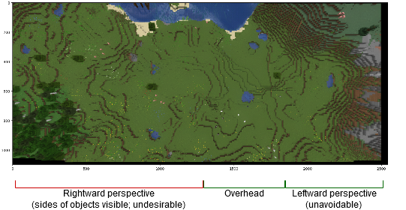

Figure 7. Image Stitching Perspective Problem

Because OpenCV's stitching pipeline does not handle perspective in the way we require, we have reevaluated our needs and discovered that this step is not truly necessary to run the system as a whole. Because the starting location of the land drone is expected to be in the first overhead view, a full color overhead map of the environment, while potentially useful for other configurations, is not vital to the system’s integration. As such, this stage of the subsystem may remain unused in the final product.

### Validation

Because the performance and accuracy of this step is beyond our control, only error handling can be evaluated. If OpenCV's stitcher returns a failed status or throws an exception, an exception will be catchable by the caller, satisfying the requirement that unrecoverable errors throw an exception.

## Depth Inferencing

### Description

The depth inferencing stage embodies the core idea behind our method of detecting obstacles, as an "obstacle" status in most cases is caused by a difference in height. This step takes an image for the "left eye" and for the "right eye" positions and produces a two-dimensional matrix of depth values inferred through the stereoscopic perspective given by the image pair.

### Algorithm

The core of the algorithm used is provided by OpenCV's “StereoSGBM” class, which itself implements a modified variant of Heiko Hirschmüller's semi-global matching algorithm. The results from this algorithm are then filtered using the WLS filter provided by OpenCV.

This algorithm has numerous parameters, which a user of the system will struggle to understand, and some of which have so great an impact on the quality of the output that they may need to be tuned by hand for each run of the system for best results. To simplify the calling interface, the parameters with the greatest effect have been determined through experimentation and only these must be provided by the caller. The remaining parameters are set to sensible defaults.

Unfortunately, because the best values for parameters with the most impact cannot be decided automatically, the user may instead have to tweak these by hand. To accommodate this requirement, a new user interface element will be included in the final product for this purpose. The user will be able to adjust sliders to change these values interactively and see their effects in real time. Once these values are decided, the rest of the subsystem will perform without issue.

### Validation

The depth inferencing stage is subject to precision, sensitivity, and performance tests. For each test input, the parameters are tweaked to be as effective as possible to measure the capabilities of the algorithm and not the effectiveness of a single set of parameters. These measurements are performed as follows:

* To measure precision, test the system over an area with many assorted objects decreasing in size and preferably with many of each object and at different angles. Find the smallest obstacle that can be consistently detected and measure its bounding box in the image. Divide this measurement by the size of the original image to acquire the final measurement in percent image size. Post-process filtering may cause the system to ignore small objects, so this measurement is useful to ensure that this has not occurred to an unreasonable degree.
  + The system has been observed to reliably detect objects <0.003% the size of the source images, passing the desired 0.1% threshold.
* To measure sensitivity, run the system over any area with a region for which the difference in elevation is known. Measure the difference in disparity values between these two regions and divide by the ratio of their real elevation difference to the drone's altitude. This yields a value of disparity per altitude and is helpful for understanding the limits of stereoscopic depth inferencing.
  + The system’s sensitivity has been measured at approximately 952 disparity per altitude, passing well over the desired value of 500.
* Processing speed is measured automatically at each runtime, in megapixels of source images per second (MP/s). This metric is to understand the effect of each source image’s resolution on processing speed. For true processing speed, the measurement can be doubled to take into account that two source images are consumed at a time.
  + The system’s self-reported processing speed has not been observed to fall below 1.6 MP/s, passing well over the desired 1 MP/s.

## Depth Map Merging

### Description

The depth map merging stage is responsible for combining the information from the depth maps of each area segment into one cohesive whole.

### Algorithm

For lack of an existing solution to this problem, a new algorithm was designed. The goal of this algorithm is to find a way of overlapping the two depth maps that introduces the least error. When these maps are overlapped poorly, an obvious "seam" can be observed where the two maps meet and their values differ. For simplicity, the word "seam" herein refers to the *difference* in pixel values between columns in two images.

To understand this algorithm, first consider the methods one might use to combine two images with a horizontal overlap in real life. Firstly, as with physical pictures, it is possible to simply lay one photo over the other. While simple, this has the disadvantage of merging the two images at the edge of one image, where the lens distortion and effects from perspective will be at their worst. Therefore, we want to "cut off" a portion of the overlapping space in the image to move the edge closer to the center, where distorting effects are lessened. There, the two images will agree spatially more easily, and the overlapped result should therefore be more accurate.

To find a good value for how much to cut off, the first section of the algorithm analyzes the seams that would be created by equally removing columns from the right and overlapping columns on the left. It chooses the seam with the least standard deviation along it, and then uses this value to decide how much to remove from the right image. The output from this hypothetical result would be unsuitable as a solution, however, because the change in perspective means that landmarks in one image will not be equally far from the edge in the other. The result is that this method of overlapping could never produce an overlap that lines up correctly. However, it will result in an amount of the overlapping map removed which should adequately avoid distortion and other local errors. This half of the process is roughly visualized in the left half of Figure 8, which shows the first stage of the merging algorithm.

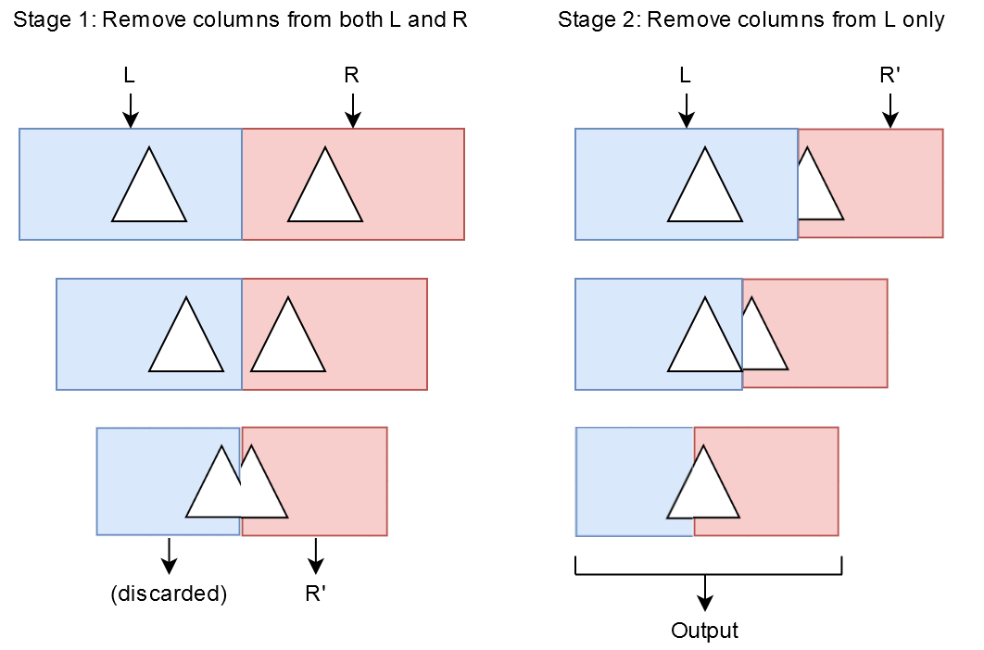

Figure 8. Depth Map Merging Algorithm

The second section of the algorithm uses the number found in the first section to test another set of hypothetical seams. This time, the same amount is removed from the right map in each case, but a different amount of the left map is overlapped each time with the resulting seam evaluated. The seam with the least standard deviation is chosen, this time finalizing the overlap between the left map and "chopped" right map. This half of the process is visualized in the right half of Figure 8, which shows the second stage of the merging algorithm.

A few potential effects are also accounted for in the algorithm. In case the right map differs in value from the left by a consistent amount, the right map is corrected by the mean difference before overlapping. If the maps are not of the same height when merged, the algorithm pads the bottom of the shorter one with zeroes. Lastly, to avoid further issues caused by lens distortion, the seams that are analyzed ignore a fraction of each map from the top and bottom.

Finally, even though this algorithm was designed to merge two maps along a single axis, it can be used with a reduction to merge several maps, and with transpositions to merge maps vertically, with a few caveats. Rotation is not considered in this algorithm, and the method of padding the end of the shorter map with zeroes arises from the assumption that the tops of each map are already vertically aligned. For merging maps over a strictly rectangular area, no camera rotation is necessary, and the alignment assumption is correct. However, these limitations mean that more complex map schemes are not possible. For the purposes of the system as a whole, however, we do not consider this limitation to be restrictive.

### Validation

The primary concern with this subsystem is accuracy, and for this reason it is tested with an accuracy measurement. The accuracy of a merge cannot be determined automatically because the ability to do so would imply having a perfect solution to the problem. Instead, accuracy must be measured manually. This process is performed by analyzing seam locations in the output and counting how many pixels away the result is from being "correct". Determining what merge would have been more correct is very challenging, however, so measuring the accuracy of this stage is difficult. In some cases, the original source images must be used to aid measurements, and in other cases there are no obvious discrepancies along a seam that can be used to measure its error.

Over 14 trials, the algorithm deviates by 5px on average for a source image width of 1920px, placing its error at 0.26%, which passes under the desired threshold of 0.5%.

## Gradient Derivation

### Description

The gradient derivation step produces a map of the environment where every pixel represents the "steepness" at that location.

### Algorithm

The algorithm used to implement the gradient derivation step is known as a Sobel filter. The implementation used in this subsystem uses Euclidean distance instead of simpler approximations but does not suffer from any noticeable lack of performance as a result. Furthermore, because the edges of the depth map are meaningless regarding the slope of the environment, the single step along both axes is implemented by a roll operation for the sake of simplicity. This technically treats the depth map as a torus, in that each edge of the map is treated as wrapping around to the other side. However, because the edges of the map are meaningless either way due to the lack of data, this simplified approach does not present any serious consequences.

### Validation

Due to the simple and mathematical nature of this subsystem, there are no addressable performance or accuracy metrics. Likewise, there are no real failure conditions other than type errors. In this instance, the Functional System Requirements dictate that an unrecoverable error such as this shall result in an exception, but this requirement is automatically satisfied by the Python interpreter, which automatically raises a type error exception in this circumstance.

For completeness, the source code for this stage is included in Appendix A.

## Obstacle Delineation

### Description

The obstacle delineation stage is the final stage of the subsystem, in which a depth map of the environment is used to construct a Boolean map of obstacle boundaries.

### Algorithm

Currently, these values represent areas which are too steep for the land vehicle to traverse. This is implemented very simply as an implicitly element-wise comparison to a threshold value. The simplicity of this algorithm comes as a direct result of the many stages before it.

The logic behind the current implementation of this stage is that large objects which would prove to be an obstacle to the land vehicle are likely so due to their height, which can be detected using the stereoscopic overhead view of the environment produced by earlier stages. Because the output representation of the environment has been intended for use over land areas only, it therefore does not account for obstacles that may cause other issues depending on the land vehicle, such as bodies of water, which are non-trivial to detect.

To account for changing requirements in the future, it is possible to modify the simple obstacle delineation stage to account for other variables or obstacle detection criteria. These changes would be internal to the subsystem and would not require any change to its interface.

### Validation

The extraordinary simplicity of the algorithm in use for this step means that no complex validation steps could be decided upon. Because this algorithm is implemented by the use of a single comparison operator (though abstracted nonetheless), there are no accuracy or performance issues that can be addressed. As with the gradient derivation step, a type error is the only failure condition, and is handled implicitly by the interpreter.

For completeness, the source code for this stage is included in Appendix A.

## Subsystem Conclusion

All of the individual stages of the computer vision and mapping subsystem are complete. Despite a couple of minor hiccups in some of the less important stages, the subsystem's components pass all their respective validation tests and are demonstrably capable of performing their necessary tasks. Furthermore, the set of subcomponents comprising this subsystem has already been integrated successfully into the full pipeline, and has been shown to perform the full transformation successfully on many sets of test data, an example of which is shown in Figure 9.

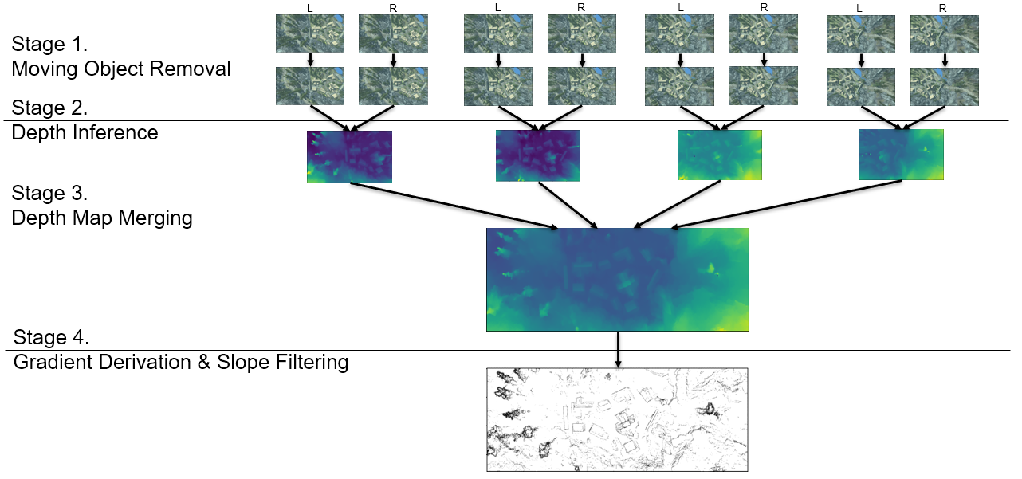

Figure 9. Full CV&M Pipeline Example

# Pathfinding and Drone Detection

## Subsystem Introduction

This is the Pathfinding and Drone Detection system design for the pathfinding of the APRS. This includes the resolution decreasing algorithm of the input map, and the pathfinding algorithm to output a proper map that will then be used to control the ground drone. For the resolution decreasing algorithm, I will be responsible for decreasing the resolution of the map to match the size of the land drone so that there will be no error in making sure that every spot traveled by the drone will be acceptable for the complete area of the drone. Currently, this program can minimize maps based on any range of pixels as long as the pixels are evenly divisible within the map’s dimensions. Attached to this system, is the pathfinding system, which will input the map at its initial resolution and the dimensions of the drone for the resolution decreasing algorithm. Below is a small diagram to show how the two programs interact with each other.

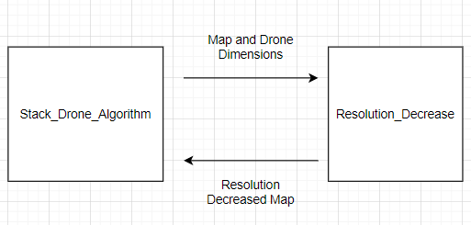

Figure 10. Software Interaction

## Stack Drone Algorithm

### Description

When deciding an algorithm to use for the drone, at first, I wanted to use recursion to recursively travel throughout a map so that any previous values can be looked over if there is a dead end. Once a dead end was found, we would then choose another path that was not taken. This idea seemed great at first, but I realized that when we had to backtrack, instead of keeping track of the data throughout recursion, it would better be kept within a stack so that it would be easier to match cases and keep storage of the data. Eventually, I settled on using a stack to keep track of the most recent paths taken, the most recent path being the coordinate on top. With the inclusion of the stack, it was easy to verify a correct course and to fix an edge case where the program would run into an infinite loop or never reach the ending location. Below is the dump of the trace of the path for a sample input as well as the final path map, and the path dumped by the stack.

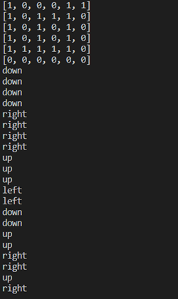

Figure 11. Sample Map

### Algorithm

The algorithm works by having a starting position, ending position, input map, and the dimensions of the land drone. The dimensions for the land the drone and the input map are sent to the Resolution_Decrease algorithm, and a new map is handed back to this algorithm. Next, this algorithm will enter a function that will start finding the path from the starting position to the ending position. The algorithm first starts with checking if the next pixel (right) is a 1 and isn’t already included in the path. If it passes these tests, it will call a function called stack_push that will add to the stack the new point and set as the current condition. This will happen for the next pixels (left, down, up) if the previous path is unavailable. In this function, after the value is added to the stack, the path finding algorithm will be called with the new point.

If all of the four options (right, left, down, up) aet exhausted, then the stack_pop function will be called. This function will pop the top value from the stack if there is a value and set the current location to the popped value, while setting the current location’s value to a 0 instead of a 1 so it knows that the path is invalid. After a value is popped, this function will also call the path finding algorithm with the new point. However, if there are no valid paths, this means that there is no valid location from start to finish and the program will end and will output a map of all 0s.

### Validation

To validate this algorithm, I first tested some basic inputs that gave a definitive answer, such as a straight line, and then traversing other directions, and then also finding dead ends. After these all worked, I tried to create a different map and ran into an infinite loop. Eventually I realized that the map I was using contained a cycle, or a path that never ends. This is where I introduced a function to check if the next point that we are going to be using was already in the stack specified earlier (Appendix B). If this function returned true, then I would treat it as a dead end and try a different path, while backtracking until there was another path found.

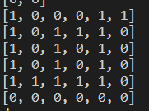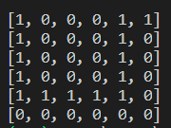

Figure 12. Cyclic Path Solved

## Resolution Decrease Algorithm

### Description

After the completion of the Stack Drone Algorithm, there needed to be a way for the drone to choose a proper path by 1 pixel. Since the input map pixels are going to be smaller than the dimensions of the drone, the input map would have to have pixels that would fit the size of the drone to ensure that every square of the drone would take an accurate path. Using a few while loops, it became possible to shrink a matrix down, with the shrunken matrix showing a 1 if all the spaces in the old map to be merged were 1s. Below is a figure of a resolution decrease of a matrix by the dimensions 2x2. As shown below, the spaces where there are 1s in a 2x2 grid starting at an even starting and ending location ((0,0), (0,2), (2,0), (2,2) for examples of the start positions) would be selected to have a 1 for the newly created pixel.

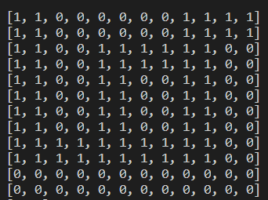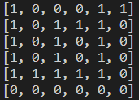

Figure 13. Decreased Resolution Map

### Algorithm

This algorithm first takes in an input of a map and the drone dimensions. Next, the algorithm creates a new matrix of the new size (current map dimensions divided by the pixels).

Next, 4 while loops are used in order to go through the two map dimensions and the two pixel dimensions. A variable is set as the value 1 (since we want to assume that the values are a 1 until we find only one 0) and then the dimensions of the pixel are searched within the map updating the location of the map to check every pixel for its value. If any one of the values is a 0, then the pixel is automatically set to a 0. This moves on throughout the entire matrix until it is filled.

After the matrix is filled, it is then returned to the Drone Stack Algorithm

### Validation

To validate this algorithm, I tested multiple sized resolution decreases among different sized maps. As shown above, the resolution decrease of a 2x2 matrix works as intended, and so does evenly divisible map dimensions to pixel dimensions as shown below in figure 6 (with a decrease of 4x2). However, anything that does not evenly divide will produce an error which has yet to be handled, and this is shown in figure 15. There are two ideas as of now: one is to take away the westmost and southmost portions of the map if there is runoff of the pixels, however this could cause some potential errors if the starting/final ending location is specified in those locations. The other idea is to try to move the drone depending on if the next pixel will fit the drone, where the next pixel will just have to match whichever dimension the drone will want to move (forward then width of drone. If downwards, then I will have to take into account the rotation of the drone and the width).

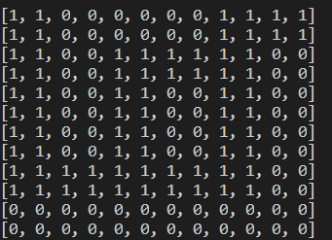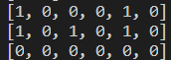

Figure 14. 4x2 Decreased Map

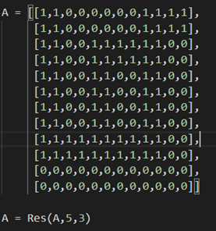

Figure 15. Error With a 5x2 Decreased Map

## Subsystem Conclusion

In these two subsystems, they have working parts and parts that can be improved on. In the stack algorithm, there are some efficiency issues which would result in many changes to the algorithm. For instance, in the algorithm, there are priorities in the directions, so if the ending location is in the direction of the least prioritized value, the drone may take a lengthy path and could potentially run out of battery. However, this algorithm does work and will always provide a path to an ending location granted that there is a valid path between the starting and ending positions.

For the resolution decreasing algorithm, the only issue is the sizing the pixels given a map. This can be solved by giving the drone a larger area so that there will not be a problem trying to ensure that the ending position does not get cut off by taking away pixels from the map. The downside of this is that there could be an optimal potential path that will not be taken because of this.

# Device Networking and User Interface

## Subsystem Introduction

The purpose of the device networking and user interface subsystem is to facilitate communication between all of the APRS devices, including the aerial drone, land rover drone, and the user’s computer. All APRS device communication, inputs, outputs, and error reporting will occur through a user interface which will be delivered as a desktop application and run on the user’s computer. Development of this subsystem included designing a network infrastructure, drone server software, and user interface.

## Network Infrastructure

### Description

Several times throughout the APRS’s operation, the systems devices need to transmit data between each other. To facilitate this, a wireless local area network approach was used. The network was configured to standard infrastructure mode, where client devices connect to wireless access points over a Wi-Fi signal.

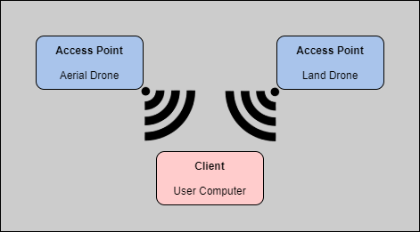

Figure 16. Overview of Network Infrastructure

For the APRS, both the aerial and land drones will act as access points in the network. This means that they will each broadcast a different Wi-Fi signal. This approach was used so that the user’s computer, or client, which is running the desktop application, can connect to the correct device for the transmission of data.

### Access Points

Onboard each drone is a Raspberry Pi 3B+. This device serves purposes defined in the Data Collection and Drone Control subsystem, but it will also be configured to allow the drone to act as an access point. To accomplish this, the TP-Link TL-WN722N wireless module was configured into access point mode using the RTL8188eus version 5.3.9 driver and various network configuration files.

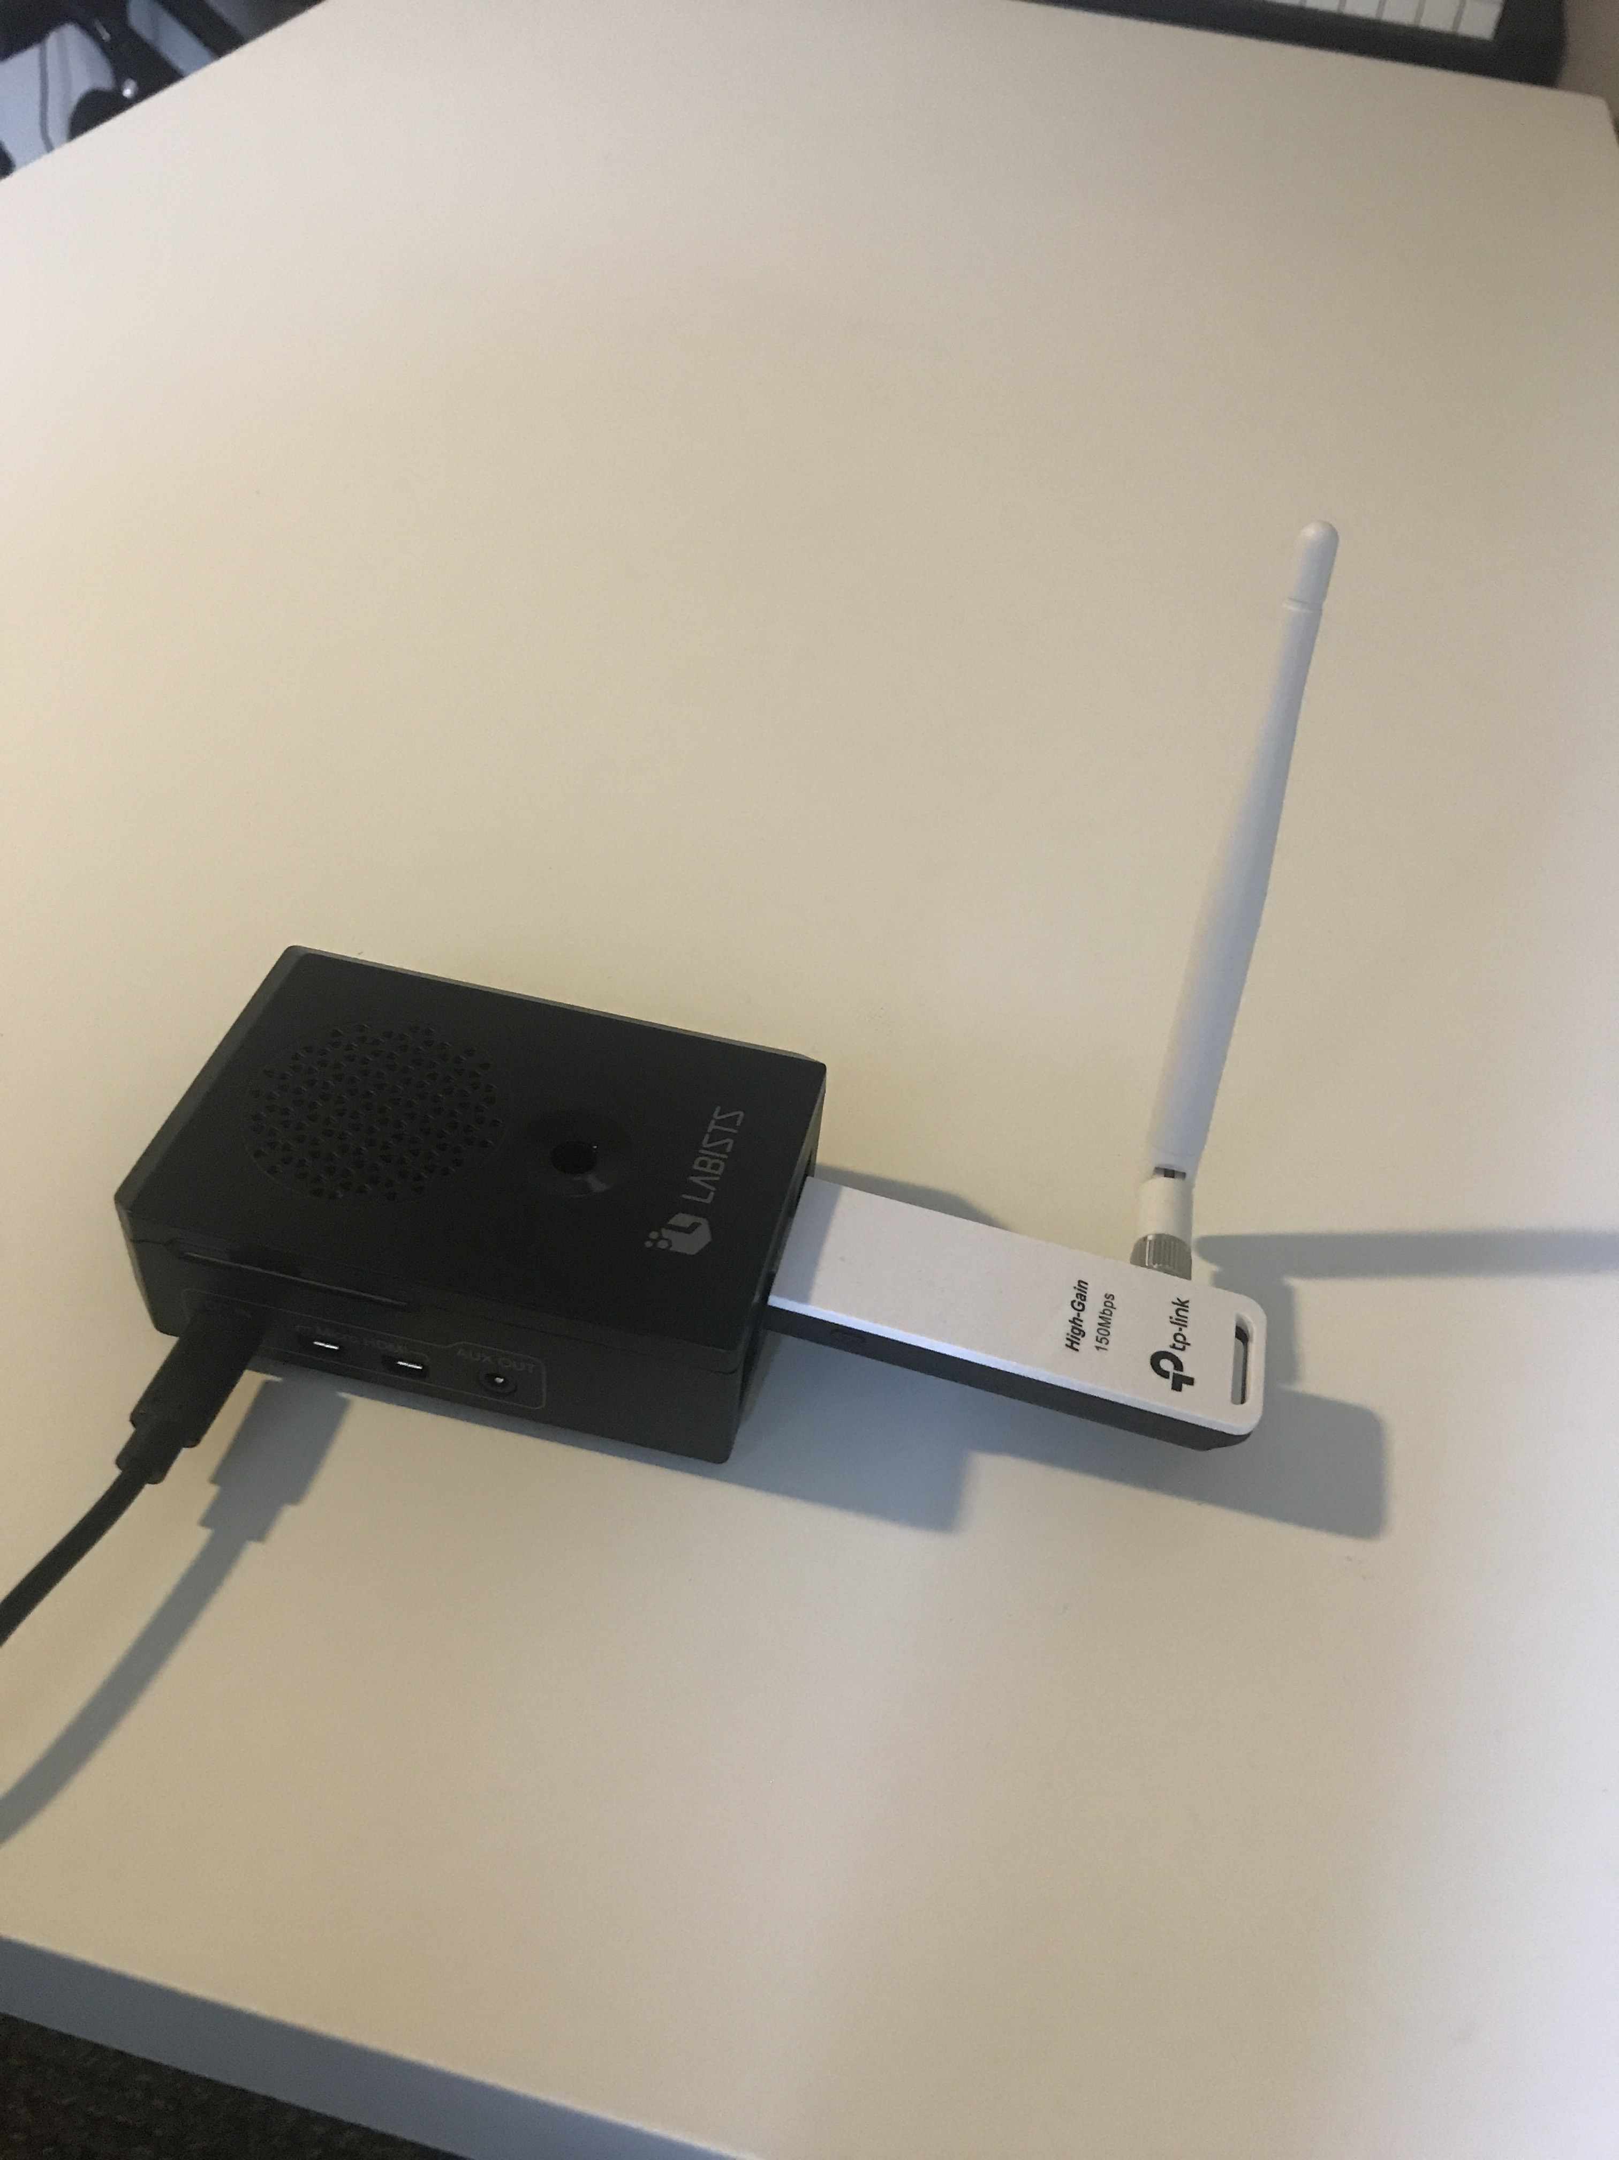

Figure 17. Raspberry Pi 3B+ with TL-WN722N

The TL-WN722N wireless module allows each drone to be connected to from up to 30 meters.

### Client

The user’s computer running the APRS desktop application will act as the client in the network. No configuration was needed to make the user’s device act as a client, meaning that any device that meets the system requirements of the APRS desktop application can be used to operate the system.

|  |  |
| --- | --- |
| **Specification** | **Minimum Requirements** |
| Processor | Intel Core I5 7th Generation or equivalent |
| RAM | 8 GB DDR3 |
| Operating System | Windows 10 |
| Storage | 5 GB |

Table 4. Client System Requirements

## Drone Servers

### Description

While the APRS network infrastructure allows the system devices to connect to each other, the Raspberry Pi 3B+ devices still require software to receive, send, and interpret data onboard the drones. To allow for this, drone server software was developed.

### Software

Using Python and the Flask web-framework, software was designed to allow the onboard Raspberry Pi device to act as a web-server, so any client devices connected to the microcontroller can send HTTP requests for data. The Flask framework defines API endpoints that receive HTTP requests from any connected client. For the purposes of the APRS, several endpoints were required on the aerial and land drone servers. Whenever one of the endpoints is requested by a client, a function within the drone server software is allowed to run.

|  |  |  |  |
| --- | --- | --- | --- |
| **Drone** | **Endpoint** | **Method** | **Function** |
| Aerial + Land | “/uploadInstructions” | POST | Save navigation instruction file from client request in drone storage. |
| Aerial | “/download” | GET | Send collected video data from flight to requesting client. |
| Aerial + Land | “/launch” | GET | Invoke function to start aerial flight or land excursion. |

Table 5. Drone Server API Endpoints

The drone server software was configured as a Linux service on the Raspberry Pis so that the process can run in the background. This allows all of the endpoints to wait until the client requests, effectively creating a RESTful API onboard each drone. The Linux service also allows the server software to be started when the drone is powered.

### Communication

All communication from the user’s computer that is running the APRS desktop application to the drone servers is done through HTTP methods. Since the drone systems will not be connected to the internet, an established connection between the client and drone must be made before any requests can be sent.

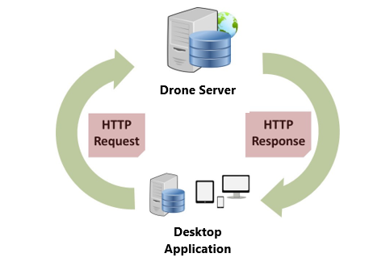

Figure 18. HTTP Request Architecture

Due to the range of the onboard Wi-Fi module, all communication between the drones and the user’s computer will happen when the drones are stationary. This is to say that the aerial drone only transmits its flight data once the entire flight has ended, and the drone has returned to its starting position. Communication between each drone and the user’s computer will occur at several points throughout the APRS’s operation:

1. Uploading of aerial drone navigation instructions from client to aerial drone
2. Initiating launch of aerial drone flight
3. Downloading aerial drone flight data to client
4. Uploading of land drone navigation instructions from client to land drone
5. Initiating launch of land drone excursion

All communication is initiated by the client. The process for the client to interact with either drone is the same. First, the client must connect to the Wi-Fi signal broadcast by the desired drone. Second, the client must send an HTTP request with the required data. Third, the client must handle the returned data. All of these steps are handled automatically by the user interface in the desktop application.

## User Interface

### Description

The user interface for the APRS will be offered as a desktop application and will serve as the sole controller for the system. Within the UI, the user will be able to define all inputs, including their current location and the system area of operation, as well as transmit the inputs to the aerial and land drones. The software that is described in the Computer Vision and Mapping and Pathfinding and Drone Detection sections will be invoked through the UI. Any outputs, and error handling will be reported to the user through the UI. Full functionality of the APRS and UI is achievable with and without an internet connection. The major components of the UI are the system area of operation mapping tool, communication tasks, and error handling.

### Application Structure

The user interface for the APRS is contained within an executable desktop application. This desktop application was developed using the following libraries, frameworks, and languages.

|  |  |
| --- | --- |
| **Library/Framework/Language** | **Notes** |
| NodeJS | Used to install dependency packages, and setup application structure |
| JavaScript/TypeScript | Main language used in developing front-end application logic |
| Python/Flask | Used to develop back-end of application |
| ReactJS | Used to develop front-end visualization and event handling |
| Leaflet | Used to develop mapping tool |
| Node-WIFI | Allows application to connect to available wifi connections automatically |
| Child_process | Allows application to spawn child processes |
| CSS | Used to style front-end |
| Bootstrap | Used to style front-end |
| ElectronJS | Used to compile HTML/CSS/JS into a desktop application |

Table 6. Desktop Application Stack

All of the dependencies listed above have been compiled into a single portable application. The application can be opened by running an executable that is contained in the portable application.

### Mapping Tool

The mapping tool contained in the user interface allows the user to define the area of operation for the APRS. The area of operation creates the boundaries of the aerial drone’s flight, and the potential land drone excursion routes. There are two steps to the mapping tool, including reporting current location and selecting a valid area of operation. The user must report their current location in terms of a latitude and longitude coordinate. Obtaining the user’s current location is important because it restricts the possible areas of operation. If the user has an internet connection, they do not have to manually input their current coordinates, we can fetch their location for them using the Google Geolocational Services. Once the user enters a valid current location, the UI will show a map that allows the user to select the area of operation.

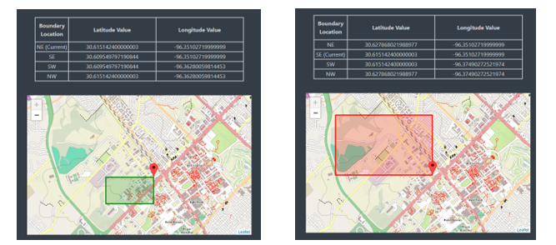

Figure 19. Mapping Tool: Valid and Invalid Selection

On the map, the user can move their mouse to define the area of operation. Per the APRS functional requirements, the area of operation must be no greater than 1 km2. If the user attempts to select an area that does not meet this requirement, the rectangle will appear red in color, and not allow the user to lock-in their selection. Once the user has a valid selection, which appears green in color, the user can click to lock-in their selection.

Once the area of operation selection has been locked-in, an algorithm is invoked to generate the aerial drone’s navigation instructions. The algorithm breaks the area into a grid made up of equally sized quadrants. The quadrant size is based on the F.O.V. limitations of the aerial drone’s camera and the altitude at which the drone will fly.

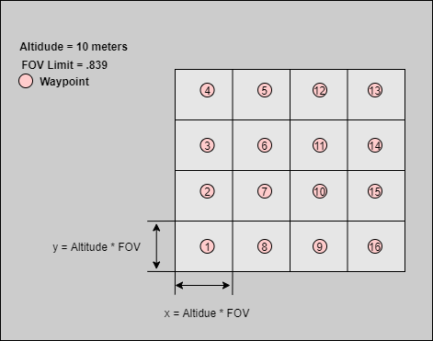

Figure 20. Map Quadrant Size

In the center of each quadrant, a waypoint made up of a single latitude and longitude coordinate is placed. This waypoint will serve as the instructions for where the aerial drone will fly to. Once all of the waypoints are placed, a navigation instruction file is created by compiling all of the waypoints. The navigation instruction file also contains a number representing the altitude at which the drone should fly at.

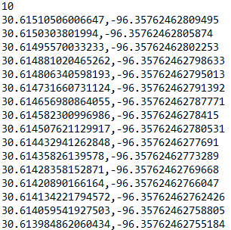

Figure 21. Navigation Instruction File

### Communication Tasks

After selecting the area of operation, the majority of the user interaction with the APRS desktop application involves transmitting data between the client and drone servers. For each of these tasks, there is a separate upload or download button to ensure that each task is completed before moving to the next. The UI provides the user updates on the data transmissions progress, such as showing a loading bar and the duration of the aerial drone’s flight.

### Error Handling

The user interface handles all errors by showing a notification with details of the error. The desktop application is organized into sequential steps, where one step cannot be started if the previous step has not yet been completed. This ensures that no race conditions occur during the system’s operation, such as attempting to send navigation instructions to the aerial drone before they are generated.

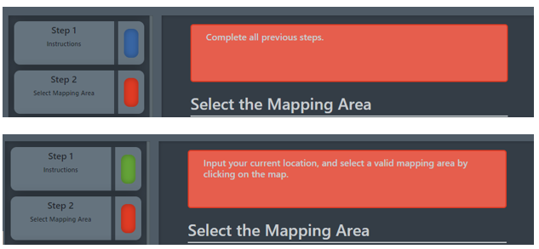

Figure 22. User Interface Error Messages

Errors are handled for the following cases:

* Attempting to start a new step with incomplete previous steps
* Attempting to complete a step with incomplete processes remaining
* Inputting invalid latitude or longitude for user current location
* Attempting to get current location from internet without an active connection
* Attempting to select an invalid area of operation
* Attempting to communicate with a nonoperational drone

## Subsystem Validation

In order to validate the Device Networking and User Interface subsystem, various tests were run to ensure the proper operation of the system was occurring. The tests ran can be broken into three categories, including networking, UI logic, and accessibility.

### Networking Validations

To complete the networking validation, tests were setup to capture the packet size and latency time when communicating between client and drone server. Additional tests were setup to validate the packet size and latency time when fetching assets from the back-end of the desktop application. The following values were obtained from the desktop application’s developer console.

|  |  |
| --- | --- |
| **Test** | **Results** |
| Fetch user's current location via geolocation api call (internet required) in under 5s | avg time to fetch = 145 ms  size of data = 442 B |
| Communicate with drone's server in under 10s | avg time to post data = 2.91 s  avg size of data = 388.38 kB |
| Fetch map images in under 5s (offline assets served by back-end) | avg time to fetch = 253ms  avg size of data = 76.3 kB |

Table 7. Network Validations

### UI Logic Validations

To complete the UI logic validation, tests were setup to assess the error handling of the application and the accuracy of the generated navigation instruction file. Through the testing of edge cases on the user interface, it can be seen that the application prevents any invalid operations from occurring. The error messages provided in the UI prevent the application from crashing and inform the user of their errors. According to the defined validations for this subsystem, the generated navigation instructions should be accurate within 1 meter. To test this, a latitude and longitude distance calculator was used. The following results were obtained from the test.

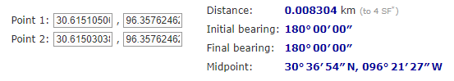

Figure 23. Coordinate Distance Calculation

The results from the calculation shows that the two waypoints from the navigation instruction set are spaced by 8.304 meters. According to the APRS mapping tool’s algorithm, they should be spaced by 8.39 meters. This falls below the threshold of 1 meter of error. Based on these tests, the following validations are passed.

|  |  |
| --- | --- |
| **Test** | **Results** |
| Error handling and message provided in GUI to prevent crash and inform user | Error messages will be presented if the user attempts invalid operation |
| Create drone navigation instructions accurate within 1 Meter | Accurate within .01 meter |

Table 8. UI Logic Validation

### Accessibility Validations

To complete the accessibility validation, tests were setup to ensure that full functionality of the application could be achieved when the source code is built into an executable. This was proven to be true by testing the operation of the system.

|  |  |
| --- | --- |
| **Test** | **Results** |
| Install software via encapsulated windows installer | create a single application containing all functionality and dependencies |

Table 9. Accessibility Validations

## Subsystem Conclusion

As it is now, the Device Networking and User Interface subsystem is setup well for the next phase of our project. Much of the functionality is complete, such as the area of operation mapping tool. Other functionality, like the communication between the desktop application and the drone servers is mostly complete, although some details may need to be fine tuned based on my team’s results from their subsystems. In these cases, the infrastructure is already setup, so fine tuning the details should not be a troublesome task. As mentioned, next semester’s work will mostly involve integrating my teammates hardware and software into the desktop application.

# Appendix A: Minor Computer Vision & Mapping Stages

def gradient_map(dispmap):

"""Gradient field derivation stage.

Implements a simple Sobel filter.

For simplicity, edges are rolled over as on a torus.

dispmap -- Disparity map to derive a gradient from

"""

# Collect vertical and horizontal differences

dx = np.roll(dispmap, 1, axis=1) - dispmap

dy = np.roll(dispmap, -1, axis=0) - dispmap

# Return Euclidean differences by sqrt(dx^2 + dy^2)

return np.sqrt(np.clip(np.square(dx) + np.square(dy), 0, None))

def mark_obstacles(grad, height):

"""Obstacle delineation stage.

For each element, set to 1 if less than threshold, 0 otherwise.

grad -- gradient field to operate over

height -- threshold to compare against

"""

# Consider any slope too steep an obstacle boundary.

return grad < height

# Appendix B: Reused Coordinate Checker

##cycle_finder will check if current is already in the list (meaning that a cycle has been found)

##this is useful in pathfinder because the conditions will include this function which

##will make sure that a cyclic path will not be taken

def cycle_finder(current):

for u in mystack:

if (current == u.current):

return True

return False